I Belong in Georgia:

Open Conference and Learning Event
Tbilisi
April 20th, 2017

Introduction
Orbeliani seeks to revolutionise aid by changing how citizens positive action in their communities. The project is non-prescriptive in its approach, in that it does not seek to shape the type of activities implemented by volunteers. Orbeliani instead provides an open funding platform, where individuals can propose ideas, receive support, and share their impact.
I Belong – an Orbeliani initiative supported by the Netherlands Embassy in Tbilisi –enables activities by volunteers seeking to promote a sense of belonging in Georgia. It envisages stronger communities, safer environments, and collaborative approaches to community problems. To date, the project has supported a total of 33 initiatives across Georgia: from LGBTIQ theatre in Tbilisi to documenting Georgia’s Islamic Heritage in Akhaltsikhe.
This document presents summarises an open conference and learning event, held in Tbilisi, Georgia on April 20, 2017. It captures discussions between project volunteers on themes of integration and belonging, as well as learning from across initiatives on how change is achieved.
The conference underscored that volunteers under the project seek to address a wide and diverse range of challenges in a range of different ways, with equally diverse impacts on their communities. This document seeks to capture these discussions, as a tool for better understanding the needs, approaches and communities of minority groups in Georgia.

Format:
The agenda was established following consultation with project participants prior to the event, and reflects the interests thereof.
- The role of social media in religious issues
- Integration through sports and arts
- Integration: challenges and solutions
- Addressing problems of the LGBTQI community in Georgia
- The role of the national language in relation to integration issues
This document does not seek to replicate the structure of the workshop, but to capture thematic learning, and key arguments and quotations to inform future activities. Furthermore, as a product of a workshop, it should be noted that the views contained within are most reflective of the most vocal workshop participants, and do not seek to represent any given community. Quotes are provided unattributed in the interests of confidentiality.

Participants
The event gathered input from volunteers from across the 33 project-supported activities, bringing together participants from Tbilisi, Kvemo Kartli, Kakheti, Samtskhe-Javakheti and Guria.
It was also attended by Mr. Petre Kankava, First Deputy State Minister for Reconciliation and Civic Equality, and Ms. Floor Nuiten, Deputy Ambassador of the Netherlands to Georgia, Bela Osipova, Head of Council on National Minorities at Public Defender’s Office, representatives of other NGOs in addition to Orbeliani staff and board members.

What volunteers seek to change
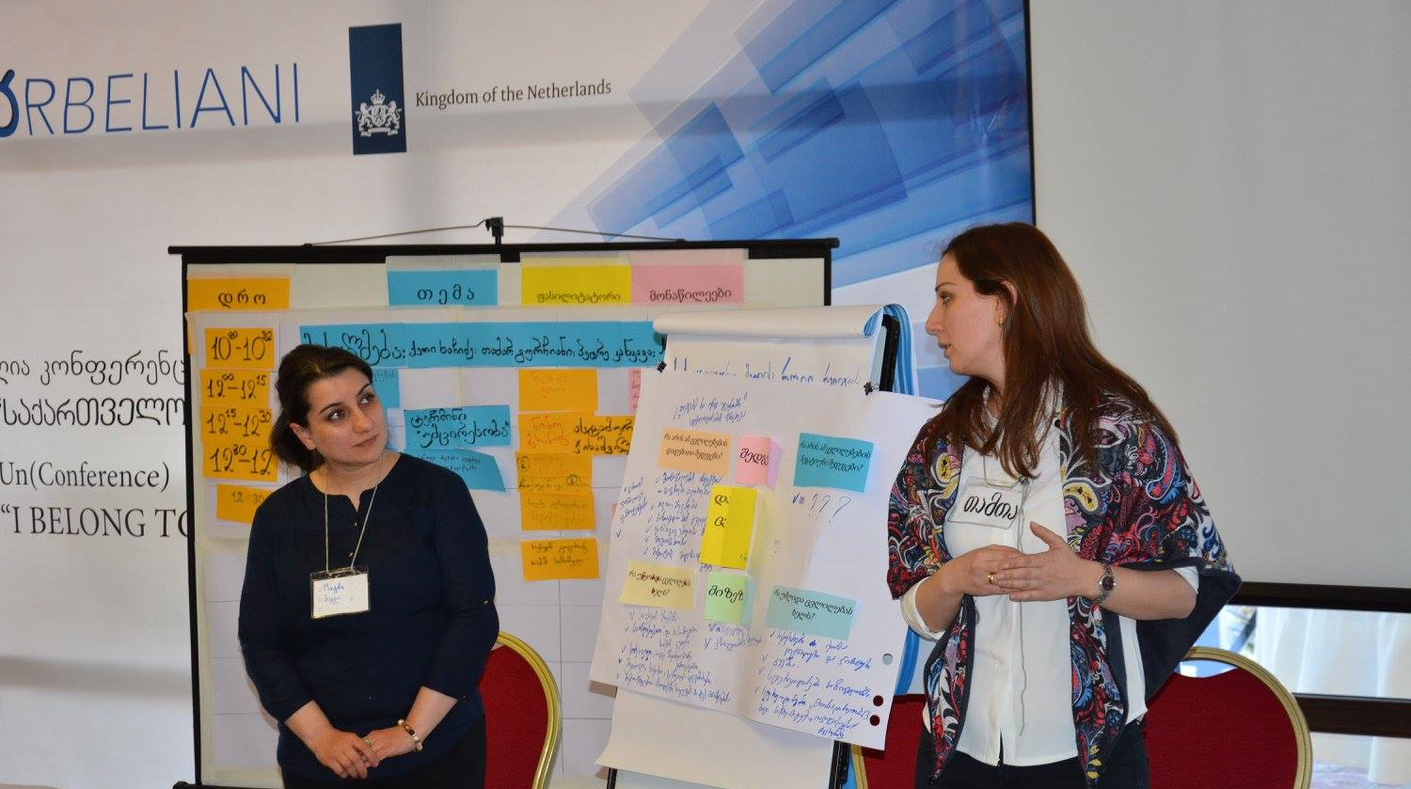
The project seeks to support individuals and groups that feel isolated or lacking a sense of belonging within their communities or Georgian society. Participants in the event frequently discussed the challenges they face and the problems their activities seek to address.

Isolation of Women and Girls
In the Pankisi Valley, one participant described how conservative values restrict social space, and limit girls’ perceptions of what they can achieve. For her, this challenge could be seen in something as simple as a youth-club table-tennis table, which was dominated by local boys at her community centre. She saw that girls in the village were keen to play table tennis themselves, but did not feel comfortable doing so in public, particularly given expectations of young women in the region. She was initially frustrated that these norms were so heavily ingrained that encouraging other girls to take part in sports was initially very difficult:
“The girls did not even imagine that it possible for them, and to begin with did not even want it.”

Religious Persecution and Crumbling Cultural Heritage
Coming from a religious minority can result in overt persecution, but it also impacts communities in slower, more subtle ways. One volunteer became concerned about the slow dilapidation of the mosques Georgia’s regions. She felt uncomfortable that the buildings are not recognised as part of Georgian heritage, despite their age and the communities that value them.
“Georgian intellectuals often don’t see mosques as part of Georgian culture, but rather as Muslim and therefore not pertaining to Georgia. These mosques are in danger – in some cases they’re used as cattle sheds and may be gone in a year or two.”
One participant felt that coming from a religious minority means they are unable to step outside of their identity and be viewed as an individual. They reported feeling that they always feel observed, and that their actions could always be used to validate or create negative stereotypes.
“If I am Baptist and I make a mistake, then people will say that Baptists are stupid.”

Knowing each other – distance and ethnic minorities
“We do not know each other in Georgia.”
Discussions struck upon the isolation and alienation of ethnic communities in Georgia. A number of participants reflected on the fact that whilst prejudice can exist within communities and between neighbours of different ethnicities, many problems stem from weak social ties between communities – something that can also exist between two ethnic Georgian villages.
Participants observed that regional stereotypes are strong, and that it is rare for rural communities from different regions to come together outside of the capital. This noted, there was greater concern for the integration of ethnic groups, which suffer more extreme isolation on a much more local scale. One participant discussed a project in Kvareli region, which sought to bring together ethnic Georgians and ethnic Avar children: they reported, with sadness, that despite living a mere ten minutes’ drive away, virtually none of the children they were working with knew each other.

LGBTQI issues
Georgia’s Lesbian, Gay, Bisexual, Transgender, Queer, and Intersex (LGBTQI) community faces severe and often violent discrimination – with numerous high profile murder cases in recent years. Violence was a major theme for participants, who reported numerous incidents in public spaces and threats from people around them.
Participants also felt discriminated against at school, university and in the work place. It was felt that discrimination by employers is particularly strong, even in the comparatively liberal NGO sector. Many laid the blame for intolerance against LGBTQI people in Georgia with the Georgian Orthodox Church, who have led protests against the community.
They noted that such problems lead to an inability in many to be themselves in public, and in extreme cases suicide.
“This is a long road and very painful and this often clams human lives, but we have to keep going.”

The media and integration
Cutting across the challenges faced by all groups represented at the event was the issue of how minorities are portrayed in the media. Some participants felt that media organisations are not interested in discussing minority issues as commercial interests dominate and minorities are not seen as a profitable market.
Multiple participants were disheartened by the fact that minorities most frequently receive coverage for negative reasons, citing reported cases of Female Genital Mutilation in the Avar community, or protests in Akhalkalaki. One participant pointed to the disproportionate coverage of the majority religion, expressing frustration that their religious holidays are not covered in the same way.
It was however noted that regional media is often more responsive to minority needs than major broadcasters, given its more niche audience and local journalists.
“Only negative news is reported from our region – this is how stereotypes are built.”

From idea to implementation – lessons learned from initiatives
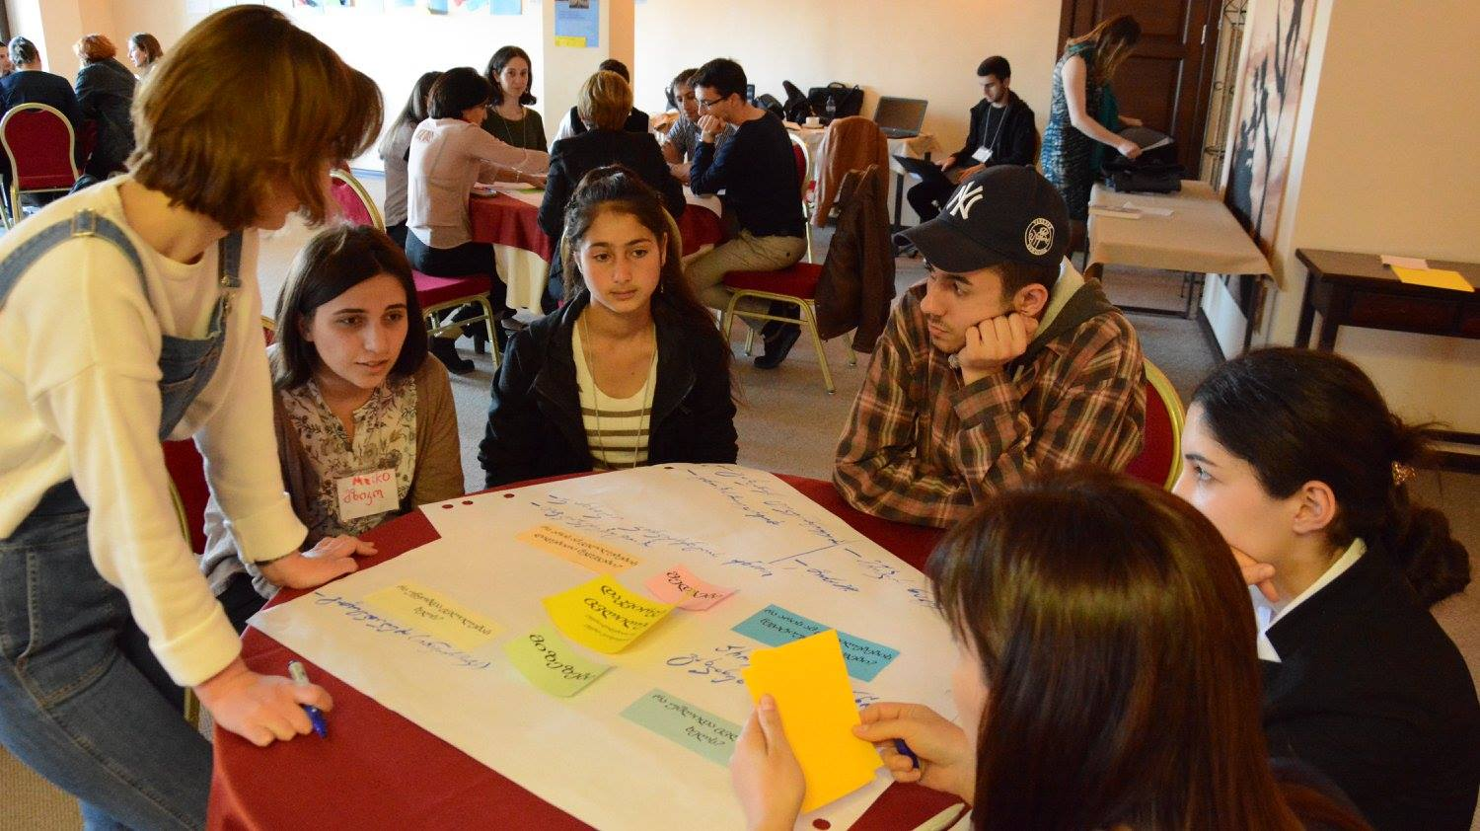
The project seeks to engage volunteers that have not previously taken part in NGO activities. Many of the participants in the discussion had not previously been involved in formal programming, and had much to say about the practical learning involved in making change.

The opportunities and risks of sport for integration
Participants agreed that sports activities for young people can be a powerful tool for breaking boundaries; and that joint activities can bring together young people from across different religious and ethnic backgrounds, creating a common language between otherwise separated groups.
“Sport can play a uniting role as sport, like art, does not have a religion or gender.”
One participant looked at sport as a means to bring groups from within a community together, and as a space where other ideas can flourish:
“When playing, we came up with lots of interesting ideas to bring change in our community. I’m particularly proud that we girls had this opportunity – it had previously seemed like a dream.”
Other participants were more cautious, saying that their experience had shown that sporting activities must be managed carefully to avoid sparking conflict between communities. One mechanism for mitigating conflict that was proposed was the use of mixed teams during football matches, to prevent excessive competition spilling over into conflict.
“[two groups] competing to prove who is smarter can be very dangerous, and may instigate more confrontation.

Making the media work for minorities
As discussed in the previous section, the media presents a number of obstacles to the integration of minorities in Georgia; participants, however, were also keen to discuss the opportunities it makes available, particularly in regard to social media.
One participant described how they had learned to use Facebook more effectively, by attracting users with related interests. They chose to use Facebook over more traditional platforms, as it grants the opportunity to reach a wider audience with little or no overhead costs. They reported considerable success in leveraging social media to attract attention from more traditional outlets, who are often happy to reuse quotes from Facebook in their reporting, as well as gaining support from other celebrities.
The same participant also noted a number of challenges with using social media for outreach, most notably that they now feel that they have to be very careful about what they say online, as they are viewed as a representative of their community.
“I feel more responsibility for what I post on my wall now, and I understood this is no longer my private space. You to be especially careful when you deal minority issues.”
Others have tried to use video to counter common stereotypes and encourage others within their communities to achieve in spite of the challenges they face.
“We want to record videos of ethnic Azeri and Armenian students studying at University, sharing their success stories, so that others back in their communities are also inspired.”

Others have worked to document social issues relevant to their communities. During the conference, the initiative group, Take Artitude, showed a film they had made with funds from Orbeliani, which documents the challenges faced by the LGBTQI community in Georgia. One volunteer from the project describes how important it was to be flexible and follow instincts when developing a documentary with highly charged emotional content.
“We wrote a script but when we started filming, and things took a completely different turn [...] it brought painful memories to life. We decided to leave the script behind and allow our emotions to come to the forefront. We were absolutely sincere, and the video includes some swearing. We could have muted it […] but we wanted to show reality.”

Part 3: Initiatives’ Impact
Participants spoke with great enthusiasm about the changes they had seen in their communities resulting from their initiatives. The impact of volunteers’ work has been diverse as the problems they have sought to address, ranging from securing official recognition of heritage sites to profound personal changes. The below represents a sample of impact discussed during the workshop.

Protecting heritage
The campaign to preserve Georgia’s Islamic heritage has been highly successful, having engaged the media and the Ministry of Culture and Monument Protection in the issue. Since the campaign began, the Ota Mosque in the village of Aspindza, Samtskhe-Javakheti, has been granted Cultural Monument status, affording it certain protections under Georgian law. Volunteers attribute their success to effective use of social media:
“We started the conversation on social media, and we were not afraid of people’s reactions. Through our activism, we have started to change local attitudes towards these places, and our efforts have already borne fruit.”

Building confidence and dialogue
The Ecumenical Interfaith Peace Theatre initiative, brings together children from across different faiths and Christian denominations in to perform together on stage. The volunteers leading the initiative reported seeing considerable improvement in attitudes towards diversity in the group, and improved individual self-confidence in the children taking part.
“Children of different religious affiliation have very little opportunity to integrate at school. When they joined the theatre, most were shy, sought to play low-key roles, and were nervous about talking in public. Since then, everyone wants to talk. We are proud to have built a confident and diverse team.”

Opening opportunities for young women
During the session, two initiatives – in Pankisi and Bolnisi – described a positive impact in terms of girls’ opportunities and self-confidence.
In Bolnisi, an activity which brought together children from Georgian and Azeri communities gave one girl the confidence and support she needed to challenge gender norms.
Do you know how ‘well-bred’ girls behave in this village? They avoid social media, they do not even come to school often and pretend they are sick. [One volunteer in the project] was missing her classes, so called and told her I wanted to speak to her about our initiative. She appeared at school ten minutes later, saw all her teachers and admitted she was not actually sick. She then stayed at school to attend a meeting about early marriage.

In Pankisi, conservative traditions had limited opportunities for young women to gather and socialise. A simple table tennis table, reports the lead volunteer under the initiative, has prompted girls from her villages to learn new skills, and think about new ways to work in their community. The next step, she believes is to encourage girls from the neighbouring ethnic Georgian community to take part, building bridges between Christians and Muslims:
“I wanted to show to local girls that they can sports too. It has allowed them to think about what they really want, and discover hidden talents. I believe that involving of Georgian girls strengthen the initiative, and develop new relationships. We want to think of more projects which will help change the community for the better.”

Increasing media diversity
Community radio has become a way that one host feels they are able to transcend stereotypes and be seen for their talents, not as a religious minority. They also were proud to be covering issues that were previously ignored, and to have gotten young people excited about journalism.
My philosophy is that when one is performing a common good, it does not matter what religion they represent. I am a community radio host, and nobody cares what my religious beliefs are. A number of young people came to our station, and have become journalists – they too are proud, and are not afraid of expressing their opinion.

Reflecting and planning for the future
Some of the most emotionally charged stories of the event came from members of the LGBTQI community. Reflecting that the battle against homophobia is long-term and challenging, participants from this group found the importance of the initiative to be internal. The lead volunteer reported that their film had brought members of the LGBTQI community together, and supported personal sharing and internal reflection – which had a strong, positive psychological impact on those involved, and had energised the group to approach their problems in fresh and innovative ways.
“The most significant achievement of Take Artitude is that the community members were able to share their personal stories and experiences of discrimination. We found the experience empowered us to find creative solutions.”

